# DESIGN THINKING ACTIVITY PLAN TEMPLATE

## BASIC INFORMATION

PROJECT TITLE:

Title of the Design Thinking (DT) Project

AUTHOR(S):

Name(s) of teacher (s), designer(s), researcher(s) who created the Activity Plan

ISSUE:

Briefly Describe the **problem** or the **topic** that the DT project addresses.

*E.g. Metal mining for jewelry production purposes has a hugely detrimental impact on the planet. In times critical for environmental sustainability, it is important for the industry to develop more sustainable methods for jewelry production.*

FINAL STUDENT PRODUCTION (project outcome):

What will students have created by the end of the project?

*e.g. a 3D model of a jewel/ a GIS simulation game for sustainable transportation in the city*

ΤECHNOLOGIES TO BE USED:

MaLT2    ChoiCo SorBET VRobotics NQuire

## FOCUS, SET UP & REQUIREMENTS OF THE ACTIVITY

### 2.1 LEARNING OUTCOMES & ASSESSMENT

You can find the Learning objectives Verbs [here](https://www.utica.edu/academic/Assessment/new/Blooms%20Taxonomy%20-%20Best.pdf)

|  |  |
| --- | --- |
| Learning Outcomes | Assessment method |
| Domain Related | |
| *e.g. 1* ***Use*** *the mathematical properties of the 3D shapes to design the digital jewel model (Mathematics)* | * *Exten(D.T.)2 Dashboard* * *Prototypes* * *Evaluation sheet* * *Rubric* * *Other:* |
| *e.g. 2* ***Decide*** *on the material for printing the 3D model (Chemistry)* | * *Exten(D.T.)2 Dashboard* * *Prototypes* * *Evaluation sheet* * *Rubric* * *Other:* |
| Design Thinking & innovation with Emerging Technologies Related | |
| *e.g. 3* ***Create*** *different prototypes of 3D models (MaLT2 & 3D printing) (Ideation)* | * *Exten(D.T.)2 Dashboard* * *Prototypes* * *Evaluation sheet* * *Rubric* * *Other:* |
| *e.g. 4* ***Interpret*** *questionnaires answers to design criteria for the model they create. (Analysis)* | * *Exten(D.T.)2 Dashboard* * *Prototypes* * *Evaluation sheet* * *Rubric* * *Other:* |
| *e.g. 5* ***Relate*** *the feedback from their peers to iterations they did to the prototype (Feedback)* | * *Exten(D.T.)2 Dashboard* * *Prototypes* * *Evaluation sheet* * *Rubric* * *Other:* |
| 21st century Skills Related | |
| *e.g. 6* ***Explain*** *their ideas to others (Communication)* | * *Exten(D.T.)2 Dashboard* * *Prototypes* * *Evaluation sheet* * *Rubric* * *Other:* |
| *e.g. 7* ***Discuss*** *different solutions to the issue at hand (Communication)* | * *Exten(D.T.)2 Dashboard* * *Prototypes* * *Evaluation sheet* * *Rubric* * *Other:* |
| *e.g.8* ***Present*** *their final artifact by demonstration (Presentation)* | * *Exten(D.T.)2 Dashboard* * *Prototypes* * *Evaluation sheet* * *Rubric* * *Other:* |

### 2.2 PARTICIPANTS & CONTEXT

#### STUDENTS

|  |  |
| --- | --- |
| Age | *e.g 10-11 years old* |
| Prior knowledge | *basic knowledge of programming concepts with Logo* |
| Nationality, gender, cultural background | *1 pupil is from Albania and 21 from Greece, 15 boys & 7 girls* |
| Language | *Greek* |
| Special needs and abilities | - |

#### TIME

ACTIVITY DURATION: *e.g. 8 hours divided into 4 times* ***(recommended duration: min 8 hours - 2 sessions)***

IMPLEMENTATION DURATION: *e.g. 4 weeks*

SCHEDULE*: e.g. 2 hours/week*

#### SPACE

ACTIVITY TYPE: In-person    At distance Mixed

PHYSICAL SPACE: *e.g. computer laboratory, classroom*

VIRTUAL SPACE: *e.g. moodle platform, Miro Platform MS-TEAMS platform, E-class*

### 2.3 SOCIAL ORCHESTRATION

#### PEOPLE INVOLVED

No of STUDENTS: No of GROUPS : No of TUTORS: No of ASSISTANTS:

#### STUDENT GROUPING & COLLABORATION

|  |  |
| --- | --- |
| Grouping Criteria | *e.g. mixed school performance, student preferences* |
| Orchestration | *e.g. 3 students per group using 1 computer per group* ***(min 2, max 5 students/group)*** |
| Roles in the group | *e.g. pre-defined roles; emergent roles; role exchange in the group (in case the roles are predefined by the teacher, provide more details about what each role is expected to be responsible for)* |
| Tutor(s) role(s) | *e.g. intervene; monitor; facilitate; guide; observe* |

### TEACHING RESOURCES

|  |  |
| --- | --- |
| Digital resources | *e.g. MaLT2 microworld with basic 2D & 3D models created by the teacher (a pyramid, a cube, a circle)* |
| Physical resources | *e.g. a 3D printed model, workbook* |

## IMPLEMENTATION - DESIGN THINKING ACTIVITY FLOW

This section describes how the teaching and learning process is expected to evolve through the 5 phases of the Design Thinking Methodology: 1. Empathise & Understand, 2. Define & Ideate, 3. Rapid prototyping & Iteration, 4. Sharing & Feedback, 5. Respond & Deliver. The described activities should support the objectives stated and make use of the technologies, supporting material, and teaching and learning processes mentioned earlier in the activity plan.

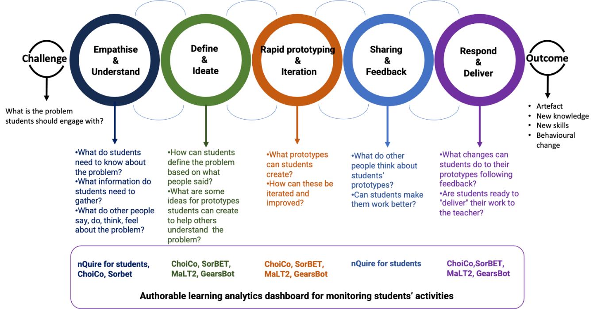

### PHASE 0: Challenge

#### Duration:

Are your students familiar with the tools. Students may find it difficult to start with the tools. Consider designing a sandbox activity, where your students are guided to make small changes n already made artifacts in order to get familiar with them.

Present to your students the visual of the DT model they are going to follow. Discuss with them and note what they are expected to do in each DT phase. Keep the visual as a guide and refer to it in the beginning and in the end of each session so that students can track the progress of their work.

|  |  |
| --- | --- |
| DESCRIPTION:  *Explain to your students the DT phases they are expected to follow.  You can use the* [*DT project visual guide.*](https://docs.google.com/presentation/d/1YX3N8BEzo0VRrvNrK9L8WJHPD0qtIorJ/edit#slide=id.p1)  *Give a short description of the challenge the project addresses. What is the problem or issue they would like to explore? What are students’  experiences regarding this issue? What are the related key concepts? What do the students already know about it? What information do they need to gather?* |  |

### PHASE 1: Empathize & Understand

#### Duration:

To save time, each group can distribute their mission to their classmates or school teachers during a recess (e.g. using tablets).

Mind that students need some time to see and analyze the data from the questionnaires of phase 1. You can do this in the classroom as a whole or ask them to do it at home

|  |  |
| --- | --- |
| DESCRIPTION:  *Students explore various aspects of the problem developing an  understanding of the issue at hand and empathize with their  potential audience, creating online surveys in nQuire asking  questions to discover their needs. When you design the  activity think about how you are going to support your  students:*   * *Which are the people involved?* * *What do they say, do, think, feel about this problem?*   You may use the following phrases to describe:  *In this phase students will use [technology/material]*  *By the end of this phase each group*  *[refer to learning outcome/digital or physical construction]*  *Students are expected to [students interactions]*  *The teacher [role of the teacher]*  COMPLEMENTARY ACTIVITIES/ALTERNATIVE PATHS:  *Provide alternative paths for your students to ensure everyone’s participation*  *What will students who finish earlier do?*  *What are alternative paths your students can follow in case they have special difficulties or preferences?* |  |

#### 